DESKTOP APPLICATION FOR JUDO MATCH

PROCESSING AND SYNCHRONIZATION

CLOUD STORAGE AND

PROCESSING

MOBILE APPLICATION FOR

RECORDING JUDO MATCH DATA

INTERNET

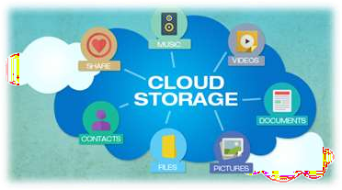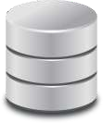

WEB SERVER STORAGE